SYSTEM DESIGN
SYSTEM DESIGN

Data Flow Diagram / Use Case Diagram / Flow Diagram

The DFD is also called as bubble chart. It is a simple graphical formalism that can be used to represent a system in terms of the input data to the system, various processing carried out on these data, and the output data is generated by the system.
Architecture

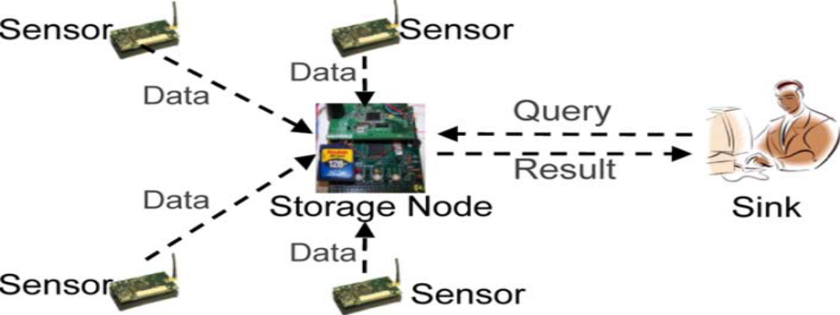

Dataflow Diagram
SENSOR NODE:
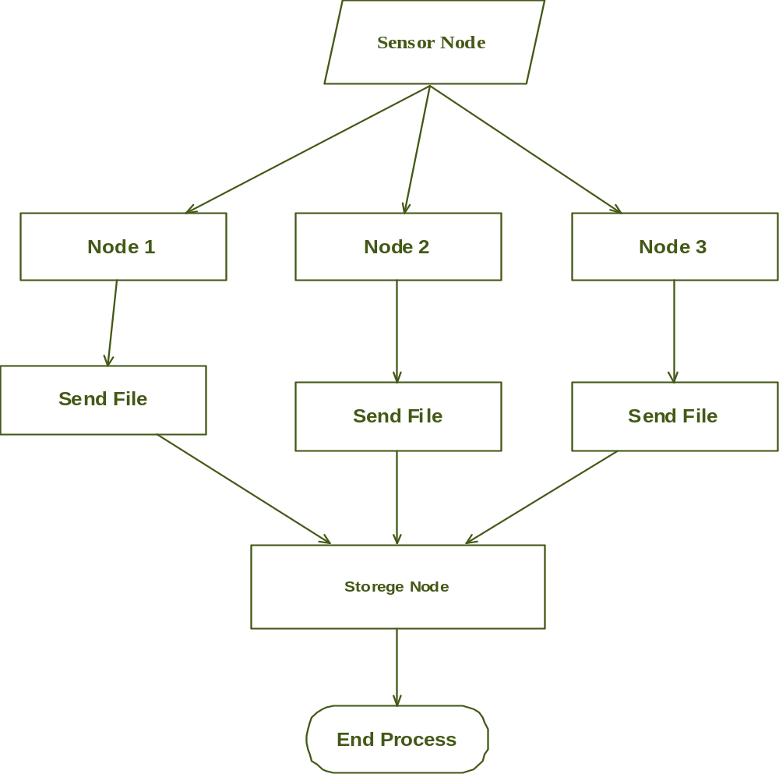

SINK :

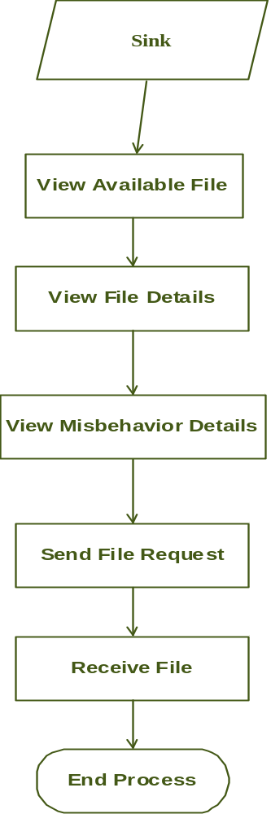

Use case Diagram:
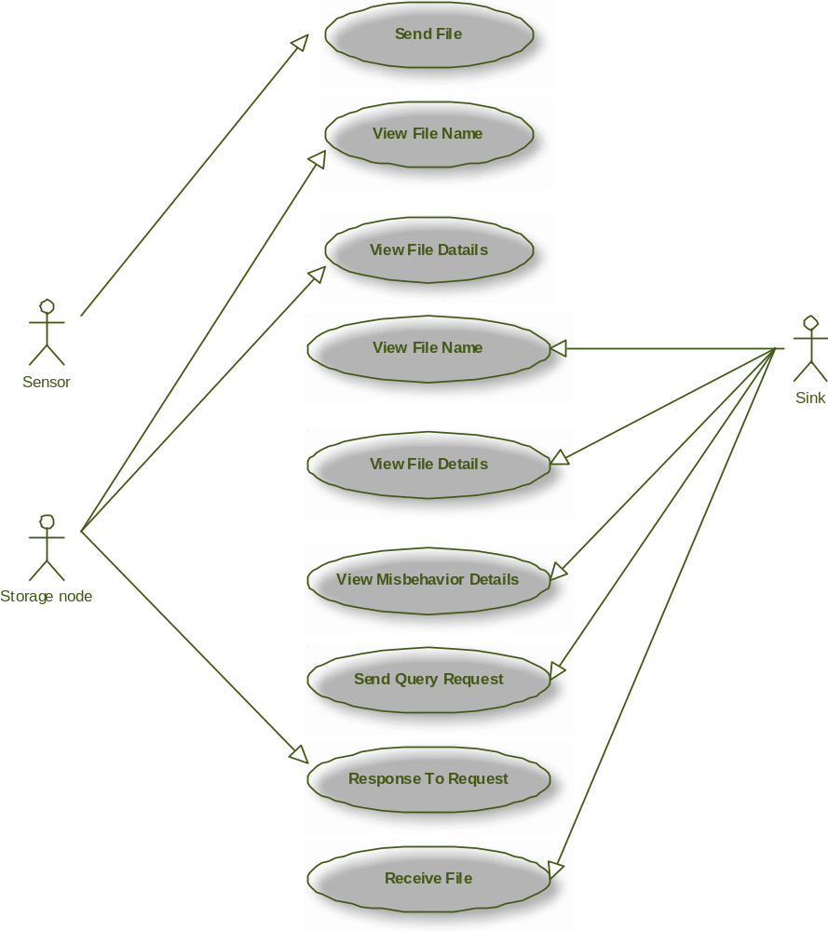

Activity Diagram:

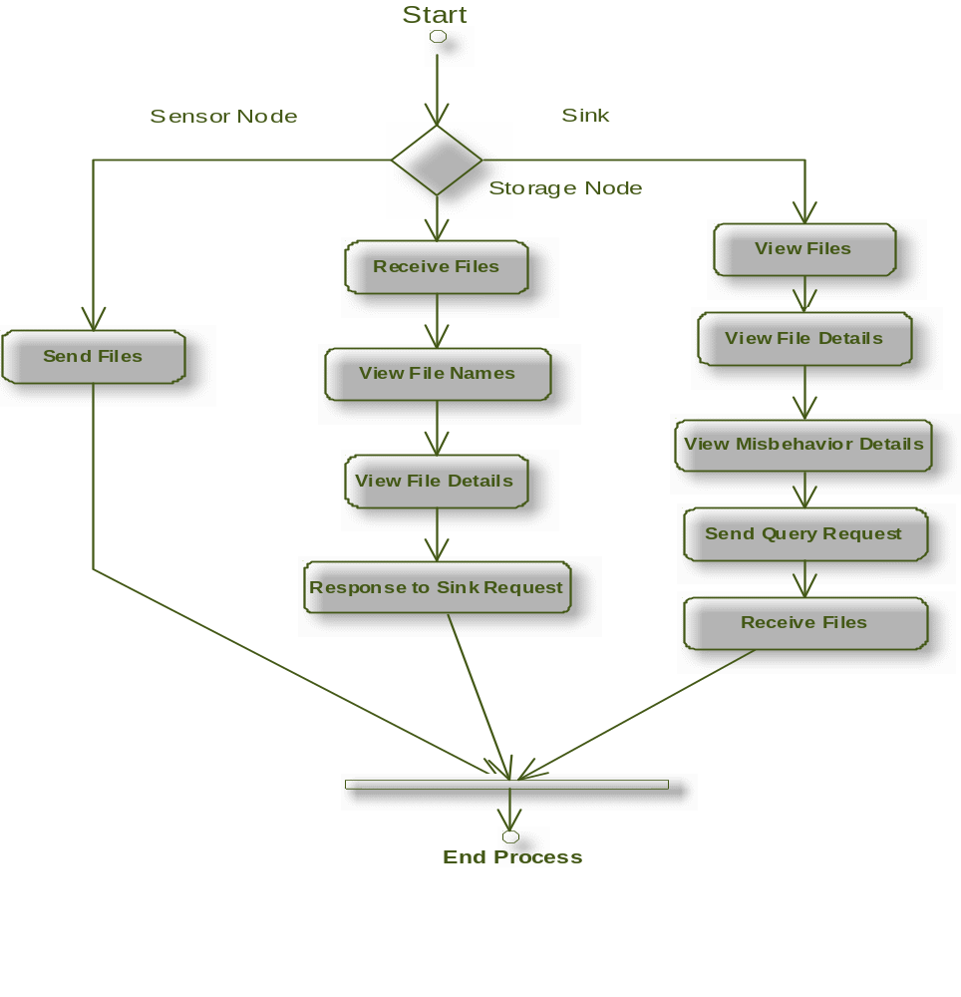

Class Diagram
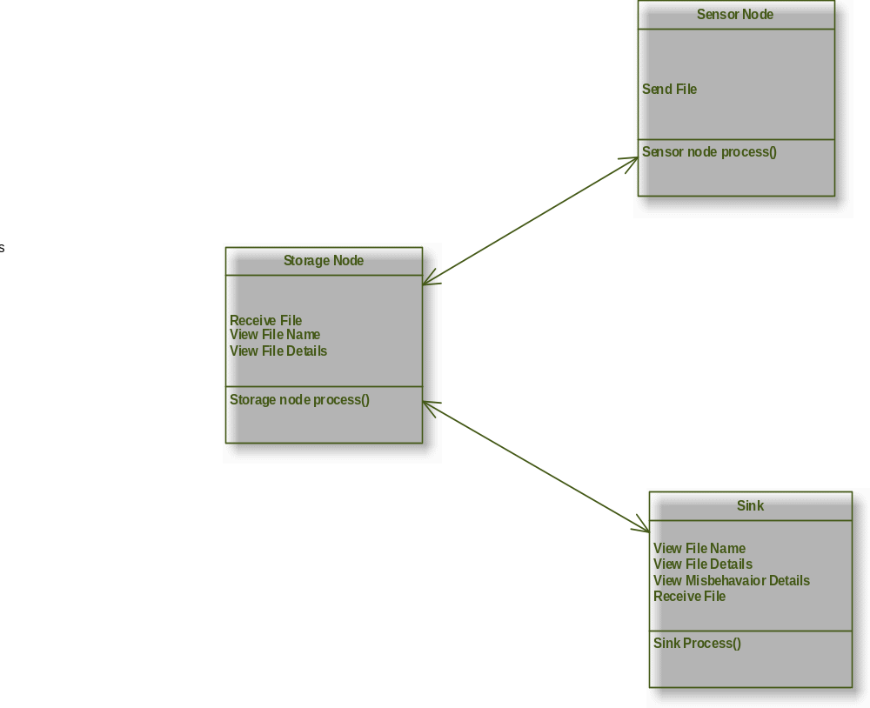

SEQUENSE DIAGRAM:

